**Microprocessor Lab**

Laboratory Activity No. 1

**Familiarization with TinkerCAD**

|  |
| --- |
|  |

Score

*Submitted by:*

**Isidro, Cheilo Marie P.**

**Sat 10:00 – 1:00 / CPE 0412.1-1**

*Date Submitted*

**16-09-2023**

*Submitted to:*

**Engr. Maria Rizette H. Sayo**

1. Exercise

a. A process in Tinkercad where we can develop electronic circuits that can be quickly updated, modified and tested is called Prototyping.

b. In Tinkercad, Start/Stop Simulation tests the working of the circuits and the components.

c. The device used to assemble and connect the various components is known as Breadboard.

d. In an electronic circuit with LED, the positive end of the circuit should be connected to

Anode and negative end should be connected to Cathode of the LED.

e. A Resistor is used to restrict the flow of current to electrical components.

2. Label the following:

1. Anode and Cathode in a LED

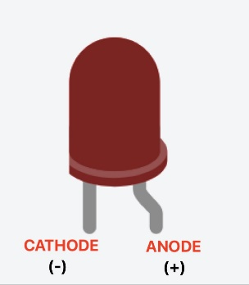

1. Different parts of breadboard

1. List the electronic components used in a circuit assembly.

|  |  |
| --- | --- |
| NAME OF COMPONENTS | PICTURE |
| RESISTOR |  |
| CAPACITOR |  |
| PUSH BUTTON |  |
| LED |  |
| MICROCONTROLLER |  |
| ULTRASONIC SENSOR |  |
| TEMPERATURE SENSOR |  |
| DIODE |  |
| INDUCTOR |  |
| POTENTIOMETER |  |
| SLIDESWITCH |  |
| 9V BATTERY |  |
| COIN CELL 3V BATTERY |  |
| 1.5V BATTERY |  |
| BREADBOARD |  |
| MICRO:BIT |  |
| VIBRATION MOTOR |  |
| DC MOTOR |  |
| MICRO SERVO |  |
| HOBBY GEARMOTOR |  |
| NPN TRANSISTOR (BJT) |  |
| LED RGB |  |
| PHOTORESISTOR |  |
| SOIL MOISTURE SENSOR |  |
| PIR SENSOR |  |
| PIEZO |  |
| MULTIMETER |  |